Process Management (Chapter 8 / technically 24, where I found this info in 7th ed.):
Management (manage your ppp, with your pp)
- Manage your People, product and process with push and pull motivation
Push and pull motivation (slide 24, week 10-1 ppt)
Push motivation means using external factors to motivate individuals, often involving pushing them towards goals or tasks using external rewards or consequences. More of a directive, managerial approach where a manager uses their external control.
Example: bonuses, promotions, or even the threat of negative consequences
In a technical environment: strict deadlines, clear targets, and rewards for meeting objectives.
Pull motivation involves creating a desire or attraction that pulls individuals towards a goal. Managers tap into their team’s internal motivation, helping them become driven by their interests, passions, or values.
Example: aligning tasks with the personal interests or strengths of the team members
In a technical environment: projects where devs can use technologies they are passionate about

"No certain answer"
- No clue wtf this is supposed to mean, you gotta fill this in

Sub-Topic: 3Ps of Proj. Management: People, Product, Process (also Project but Yang doesn’t touch on it in slides)
What are People?
People are the most important contributors to a successful software project.
Stakeholders
Four (really five) types of stakeholders in a project:
Senior managers who define project business issues / details, and Project (technical) managers who must plan, motivate, organize, and control the project practitioners (devs).
Practitioners who deliver the technical skills that to engineer a product (developers basically).
Customers who specify the requirements for the software to be engineered + other stakeholders who have an interest in the project outcome (consumers).
End users who interact with the software once it is released for production use.
MOI Model
Competent practitioners often make poor team leaders, as they might not have the proper people skills to be effective. Successful leadership can be found by following the MOI model:
- Motivation. The ability to encourage (by “push or pull”) technical people to produce to their best ability. (see above for push and pull)
- Organization. The ability to mold existing processes (or invent new ones) that will enable the initial concept to be translated into a final product.
- Ideas or innovation. The ability to encourage people to create and feel creative even when they must work within bounds established for a particular software product or application.

Organizational Structure (Three Paradigms)
The organization of the people directly involved in a new software project is something the project manager should consider. For better or worse, organizational structure cannot be easily modified.
Org structure can be defined b/w three paradigms: (page 651 in text for more deets)
- A closed paradigm structures a team along a traditional hierarchy of authority. More likely to replicate previous successes, less likely to be innovative.
- A random paradigm structures a team loosely and depends on individual initiative of the team members. Random paradigm structure excels when innovation or technological breakthrough is required, struggles when “orderly performance” is required.
- An open paradigm attempts to structure a team in a manner that has some of the rigidity of the closed paradigm but also the flexible innovation of the random paradigm. Work is performed collaboratively, with heavy communication and consensus-based decision making.

Coordination and Communication Issues
To deal with coordination and communication issues effectively, you must establish mechanisms for communication among team members and between.
- Formal communication is accomplished through writing, structured meetings, and other relatively non-interactive and impersonal communication channels.
- Informal communication is more personal. Members of a software team share ideas on an ad hoc basis, ask for help as problems arise, and interact with one another on a daily basis.

Bonus: People Capability Maturity Model (People-CMM) key practice areas for devs:
staffing, communication and coordination, work environment, performance management, training, compensation, competency analysis and development, career development, workgroup development, and team/ culture development, and others

What is Product?
The object produced by a project (duh)
As a software developer, you and other stakeholders must meet to define product objectives and scope. This process begins as part of system / business process engineering and may continue as the first step in requirements engineering.

Estimating project scope details
Help! There are changing requirements and detailed analysis will take too long! Quantitative estimates and an organized plan are required, but solid information is unavailable. How can I determine scope?
- Context. How does the software fit into a larger system, product, or business context, and what constraints are imposed because of it?
- Information objectives. What customer-visible data objects are produced as output from the software? What data objects are required for input?
- Function and performance. What function does the software perform to transform input data into output? Are any special performance characteristics to be addressed?

What is Process?
The means by which a project is completed.
A software process provides the framework that informs software development. Some framework activities are applicable to all software projects, regardless of their size or complexity.
Task sets (tasks, milestones, work products, and quality assurance points) adapt framework activities to the characteristics and requirements of the project and its team.
Umbrella activities (software quality assurance, software configuration management, and measurement) cover details of the process model, are independent of framework activities and occur throughout the process.

This photo was given with zero context in slides. James pls fix if u remember what he said in class🙏
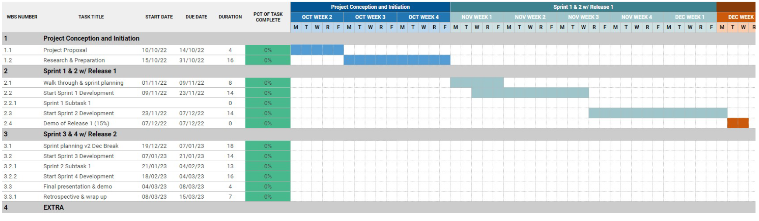

Management Strategies to avoid Process Failure
- Start on the right foot. Work very hard to understand the problem, then set realistic objectives and expectations for everyone working on the project. This is reinforced by building the right team and giving the team the autonomy, authority, and technology needed to do the job.
- Maintain momentum. Many projects get off to a good start and then slowly disintegrate.
To maintain momentum:
- The project manager must provide incentives to keep turnover of personnel to a minimum.
- The team should emphasize quality in every task it performs.
- Senior management should stay out of the team’s way.
- Track progress. Software project progress is tracked as work products (models, source code, sets of test cases) which are produced and approved (using technical reviews) as part of a quality assurance activity. Software process and project measures can be used to compare progress to organizational averages.
- Make smart decisions. Project manager and software team decision philosophy should be to “keep it simple.”
Whenever possible:
- use existing software components or patterns
- avoid custom interfaces when standard approaches are available
- identify and then avoid obvious risks
- give more time than you think is needed for complex or risky tasks
- Conduct a postmortem analysis. As project manager, make sure to reflect on project after completion. Evaluate the planned and actual schedules, analyze project metrics, get feedback from team members and customers, and record findings in written form.

Push/pull motivation Sprint planning
Nothing specifically mentioned for this in text or slides. Wouldn’t be surprised to see something like this as a question, just use your brain to connect push/pull situations (above, top of doc) with agile process details (just below)

Highly Associated w/ agile process
Agile philosophy encourages:
- customer satisfaction and early incremental delivery of software
- small highly motivated project teams, informal methods
- minimal software engineering work products
- overall development simplicity.

Agile process models give teams autonomy to make the project management and technical decisions required to get the job done. Planning is kept to a minimum, and the team is allowed to select its own approach in line with business and organizational requirements. The agile team works together and adjusts how they do things to benefit the project, often by having daily meetings to plan and coordinate their tasks.
An agile team is a self organizing team that has autonomy to plan and make technical decisions.

TLDR:
Push motivation -> incentive to do it, Pull -> you inherently want to do it
4 types of stakeholders
MOI model of leadership
Three paradigms
Start on the right foot, maintain momentum, track progress, make smart decisions, conduct post-mortem analysis

Other minor points from 2nd set of slides (Week 10-2)
Goal of a project is to produce an object (project)
Project tasks, project output, WBS + examples, milestone definition + examples + task vs milestone classification
Nothing in the 2nd slide set was mentioned in James’ review note so I skipped it in this review note. Also mentioning slides over textbook b/c for this chapter material was more streamlined in slides than text and I doubt he tests off of material not taught in class (death penalty level offence)

